**LEBANESE AMERICAN UNIVERSITY**

**USAID – HIGHER EDUCATION SCHOLARSHIP PROGRAM**

**HES - Volunteering Program Verification Form**

This form is to be used to document volunteering hours. If a student volunteers for multiple organizations, a separate form must be used for each organization. **This form must be turned in by the 28th of each month, the latest.**

I certify that the scholar mohamad ahed abou houran completed a total of 1 hours of service at Life Sculptor.

The hours were completed hours as per the below:

Hours # 0 (date) _02/09 - 06/09_ (initials of supervisor) __A.K.___

Hours # 0 (date) _09/09 – 13/09_ (initials of supervisor) __A.K.___

Hours # 0 date) _16/09 – 20/09 (initials of supervisor) __A.K.___

Hours # 1 date) _23/09 – 27/09 (initials of supervisor) __A.K.___

Brief description of the activities the scholar performed or participated in:

I performed a research on how to Discuss scalability issues , energy consumption concerns,and market volatility.  
Cryptocurrency security and fraud :  
Analyze security threats and measures in the cryptocurrency ecosystem.  
Present case studies of security breaches.

Written feedback about the scholar’s performance:

Mohamad conducted research on scalability issues, energy consumption, and market volatility in cryptocurrencies. He also analyzed security threats and measures within the cryptocurrency ecosystem, including case studies of security breaches. His research reflects strong analytical skills and the ability to explore complex financial and technological concepts.

Please rate the overall performance of the scholar at your organization:

|  |  |  |  |
| --- | --- | --- | --- |
|  | Mastery (5) | Proficient (3) | Emerging (1) |
| **Problem solver** | X |  |  |
| **Engaged & Committed** | X |  |  |
| **Open-minded & multicultural** | X |  |  |

Signature

& stamp

__________________________

_

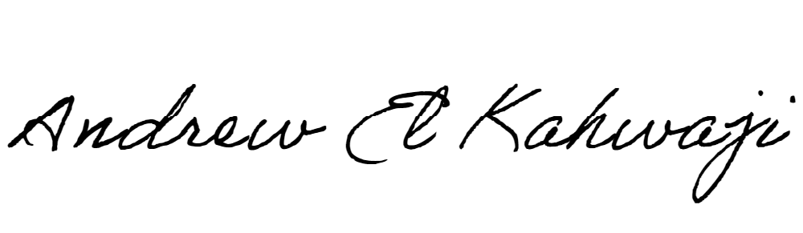

Printed Name _Andrew El Kahwaji_

Date __25/09/2024___

Email __andrew.lifesculptor.coo@gmail.com __

Phone __+961 71 914 378__

**LEBANESE AMERICAN UNIVERSITY**

**USAID – HIGHER EDUCATION SCHOLARSHIP PROGRAM**

